Worksheets – The Life of Muhammad (Pictogram Book)

Prophet Muhammad's early life
Muhammad was born in the year of the

The king of Yemen was

He wanted to demolish the

Muhammad's mother's name was

His father's name was

Muhammad's mother died when he was

After his mother died he was looked after by his

Muhammad's first job was a
Abdullah | 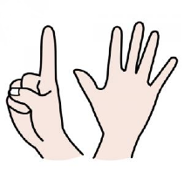  Six | 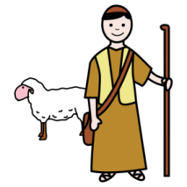  Shepherd | Amina
Elephant | 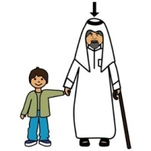  Grandfather | Kaaba | 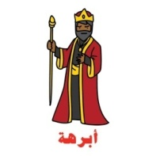  Abraha

Prophet Muhammad's midlife

Later he worked for a woman called

Muhammad married Khadija when he was

Khadija liked Muhammad because he was

An angel came to Muhammad in the cave of

The Angel was called

The angel brought down verses from the

The first verse ever revealed was

Muhammad invited people to the religion of

He invited people to believe there is no God but

The first man to believe was

The first woman to believe was

Abu Bakr | Khadija | Honest | Allah
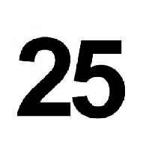  Twenty five | Hira | 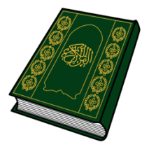  Quran | Khadija
Jibril | 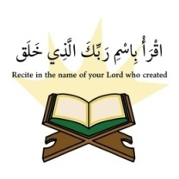  Iqraa/Read | Islam

The migration

Muslims were scared of the tribe

Quraysh used to worship

Muslims escaped from Quraysh and went to

The old name for Madinah is

Muhammad also escaped from Makkah.
He escaped with

They hid in a cave called the cave of

them.
Quraysh tried to find them but could not

Muhammad arrived in Madinah. People sang and
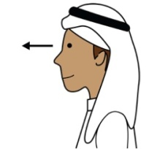  See | Thawr | Celebrate | 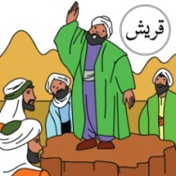  Quraysh
Abu Bakr | Madinah | 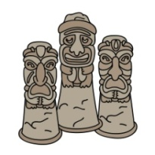  Idols | Yathrib

The spread of Islam

Quraysh fought Muslims in main battles

The Muslims won and ruled over

After that thousands of people entered

Muhammad did his last hajj 10 years after

Muhammad died in the city of

He died in the arms of his wife

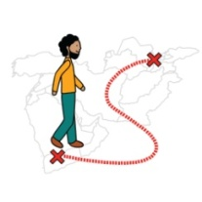  Migrate | Aisha | 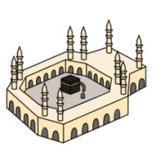  Makkah
Three | Islam | Madinah

